Migration Plan
For
Odisha Aadhaar Authentication Framework

Submitted To
Odisha Computer Application Centre
Department of Information Technology & Communication,
Government of Odisha

OAAF: Migration Plan | 18th Aug , 2023

REVISION HISTORY
REV | Description of Change | Author | Effective Date
1.0 | Creation of the Document | Shaikh Md Zeeshan | 18-Aug-2023
1.0 | Reviewed | Rohan Ray | 23-Aug-2023
1.0 | Approved | SEPG | 01-Sep-2023

INDEX
1 Introduction 4
1.1 Purpose of Migration 4
1.2 Scope of Migration 4
1.3 Definitions, Acronyms, and Abbreviations 5
2 Roles & Responsibility 5
3 Assumption, Constraints and Risks 6
3.1 Assumption 6
3.2 Constraints 7
3.3 Risks 7
4 Migration Requirement and Responsibility. 7
5 Migration Flow chart 10
5.1 Target Database Design: 11
6 Current Environment Analysis 11
7 Migration Approach 11
8 Migration strategy 12
8.1 Activity and Timeline 13
9 Backup & Rollback Plan 13
9.1 Backup 14
9.2 Rollback 14
10 Go Live & Post Migration Activity 14
11 Post Migration Activities 15

Introduction
- Aadhaar Authentication Framework portal, a single centralized platform provides the citizen of Odisha with a distinct digital identity and unique profile. This is helping the department authority to map all the services which the citizens are entitled for. It also allows the departmental officials to track the daily authentication status, success / failure transaction on a day to day process.
- One of the major milestone of this project is to migrate the application backend/database from MySQL to Oracle 19C as an up gradation step. The document describes the purpose, scope and steps to migrate data to the new database. This also outline the migration approach, strategy based on the information gathered during the requirement phase.

Purpose of Migration
- The purpose of Migration Plan for moving from MySQL to Oracle is to outline a structured and organized approach for transferring data and database structures. It will provides a clear and documented strategy for the entire data migration of Odisha Aadhaar Authentication framework project, ensuring that all stakeholders understand the objectives, scope, and steps involved. Ensures that data is transferred accurately, with minimal errors or discrepancies, and that data integrity is maintained throughout the migration.

Scope of Migration
- The scope of a migration from MySQL to Oracle for OAAF project involves
- Specifying the databases, tables, and records that will be moved from MySQL to Oracle.
- Identification of source database and its numbers of schemas and objects need to migrate.
- Identification of source database object data type need to be convert source to target ( MySQL to Oracle )
- Migration of each objects and it’s magnitude for space estimation.
- Dependencies between database objects, tables that may impact the migration process.
- Define the planned downtime for the migration, specifying when the final cut-over to Oracle will take place
- Roles and Responsibilities of the migration
- Activities after the migration is complete
- Rollback plan in case the migration encounters unexpected issues

Definitions, Acronyms, and Abbreviations
- In this document following abbreviations are used to improve the quality and better understanding of the document
SL# | Term | Definition
1 | OAAF | Odisha Aadhaar Authentication Framework
2 | OCAC | Odisha Computer Application Center
3 | OSDC | Odisha State Data Center
4 | DBA | Data Base Administrator
5 | SA | System Admin
6 | ODBC | Open Database Connectivity
7 | ODI | Oracle Data Integrator
8 | SAS DI | Statistical Analysis System Data Integrator
9 | SEPG | Software Engineering Expert Group

Roles & Responsibility
Migration Roles and Responsibilities
Role | Responsibility
Project Manager | - Oversees the entire migration ensuring it stays on track, meets objectives  - Coordinates and communicates with stakeholders  - Ensuring resource allocation and availability
PL/SQL Developer | - Develop scripts to deploy the PL/SQL code and associated objects to the Oracle DB  - MYSQL procedure and view rewritten on oracle  - Compiling validating object’s like view procedure as per requirements.
DBA | - Responsible for the technical aspects of database migration, including schema mapping and data transfer.  - Creates and manages table spaces and users  - Create Schema’s  - Manages data migration tools and scripts  - Ensures data integrity and security.  - Optimizes database performance post-migration.
System Admin | - Manages network and infrastructure considerations to support the Oracle environment  - Ensures network connectivity between applications and the Oracle database
Business Analyst | - Represents the business or end-users' interests, ensuring that the migration meets their needs.  - Defines migration requirements from a business perspective.  - Provides feedback on data validation and user acceptance testing.  - Ensures that the migration aligns with business goals
Tester | - Data validation and it shape and format.

Assumption, Constraints and Risks

Assumption
Below are assumptions for migration from MySQL to Oracle
- Infrastructure in terms of server (ExaCC), software, licenses and network setup are available in OSDC
- Access privileges for both source and destination provided during the migration period.
- The data in the MySQL database is consistent, accurate, and up-to-date
- There will be planned downtime during the migration process, and it has been scheduled at a time that minimizes disruption to operations.
- Assuming that comprehensive backups of the MySQL databases have been successfully created and can be used for restoration in case of issues during migration.
- Necessary resources, including personnel, tools and hardware, are available throughout the migration process

Constraints
Below would be some constraints with migrating from MySQL to Oracle in Odisha Aadhaar authentication project.
- Queries and stored procedures written for MySQL may require modification to work correctly in Oracle
- Mapping MySQL data types to Oracle equivalents can be complex and may require data transformation during migration
- Constraints e.g., primary keys, foreign keys, unique constraints in MySQL may need to be redefined to match Oracle's constraint syntax and behavior.
- MySQL uses AUTO_INCREMENT columns, while Oracle uses sequences. Migrating auto-increment columns to Oracle sequences can be challenging
- Migrating stored procedures and user-defined functions from MySQL to Oracle often requires rewriting code due to syntax and feature differences
- Date and time functions and formats vary between MySQL and Oracle, requiring adjustments to date-related code during migration
- Planned downtime during migration is often necessary, but minimizing downtime is a challenge. Ensure that downtime is well-coordinated and communicated to minimize disruptions

Risks
Below would be some risks in the project while migrating from MySQL to Oracle in OAAF project.
- There is a risk of data loss during migration due to errors in data extraction, transformation, or loading processes. Ensuring data integrity throughout the migration
- Applications that were designed to work with MySQL may need significant modifications to function correctly with Oracle, potentially causing compatibility issues.
- Large Table offline migration through oracle SQL Developer tool could be a challenge as the current transaction table size is more than 1 TB. In such case support from oracle professional service would be taken. As an alternative solution Oracle ODI/ SAS-DI can be used for this purpose.

Migration Requirement and Responsibility.
- Below are the requirements for AAF migration
- Windows high configure system with 16 Core CPU and 64 GB RAM.
- Oracle SQL Developer Tools.
- MySQL JDBC connector.
- Direct Network connection to MySQL Server Database ( with intermediate system )
- Direct Network connection to Oracle Server Database ( with Intermediate system )
- Oracle SAS-DI or ODI connection to Source (MySQL) and Target (Oracle). Large data migration solution to be provided by Oracle. If the feature is not available then the same can be done through SAS-DI tool.

SL# | Pre-requisite Item | Type | Memory | Core | Responsibility
1 | VM 3 nos. | WINDWOS (1) , LINUX(2) | 64 GB for windows, 32 GB for LINUX | 16 Core CPU | OCAC
2 | SQL DEVELOPER TOOL | Windows Version 22.2.0.0 or above | NA | NA | CSM (Tool should be downloaded in Pre Prod environment)
3 | MySQL JDBC connector | j-8.1.0.jar | NA | NA | CSM ( Download from Oracle site)
4 | MySQL to Oracle port connectivity | NA | NA | NA | OCAC
5 | SAS-DI | NA | NA | NA | OCAC
6 | Oracle 19c Client on SAS-DI | NA | NA | NA | OCAC
7 | Linux ODBC Setup on SAS-DI | NA | NA | NA | CSM (ODBC driver setup by team)
8 | Read only user on MYSQL SERVER for SAS-DI | NA | NA | NA | OCAC
9 | MySQL Port Access to Oracle database and SAS-DI | NA | NA | NA | OCAC

VM 3 nos. specification
VM Specification
SL# | System/domain  Name | OS | Purpose | Core | Memory  (GB) | Storage
1 | oaaf-pp-01-db | RHEL 7.9 | Oracle DB Server | 16 | 32 | 100 GB +  3 TB
2 | oaaf-pp-02-db | RHEL 7.9 | MySQL DB Server | 16 | 32 | 100 GB
3 | oaaf-pp-window | Windows Server 2019 or Higher | SQL Developer | 24 | 64 | 500 GB

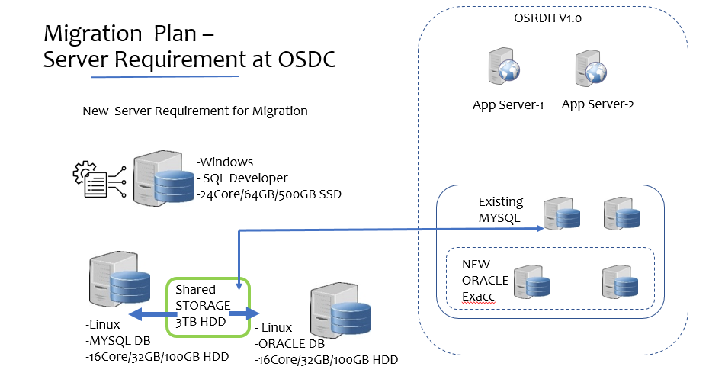

4.1 Migration Infrastructure Setup at OSDC Activity and timeline
SL# | Activity Name | Start Date | End Date | Responsibility
1 | VM-1 MYSQL SERVER LINUX | 02-Sep-2023 | 02-Sep-2023 | OCAC
2 | VM-2 ORACLE SERVER LINUX | 02-Sep-2023 | 02-Sep-2023 | OCAC
3 | VM-3 Windows Server | 02-Sep-2023 | 02-Sep-2023 | OCAC
4 | MYSQL Database Installation | 04-Sep-2023 | 04-Sep-2023 | CSM
5 | MySQL Database Backup Restoration | 04-Sep-2023 | 04-Sep-2023 | CSM
6 | Oracle Installation and Database PDB Creation | 05-Sep-2023 | 05-Sep-2023 | CSM

Migration Flow chart

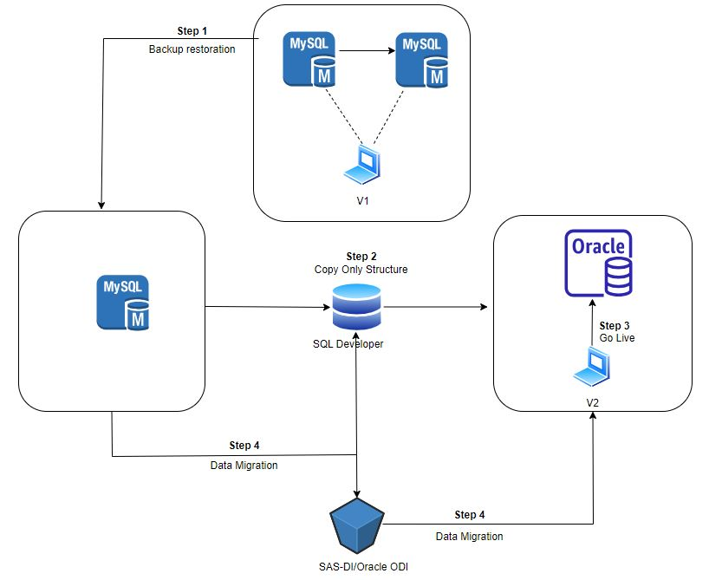
Step 1:- Back up from the MySQL Server and restore on intermediate MySQL VM
Step 2:- Capture the structure and copy it to Oracle Server
Step 3:- Connection with the version 2 application with Oracle database
Step4:- Migration of data, MySQL to Oracle using SQL developer and SAS DI

Target Database Design:

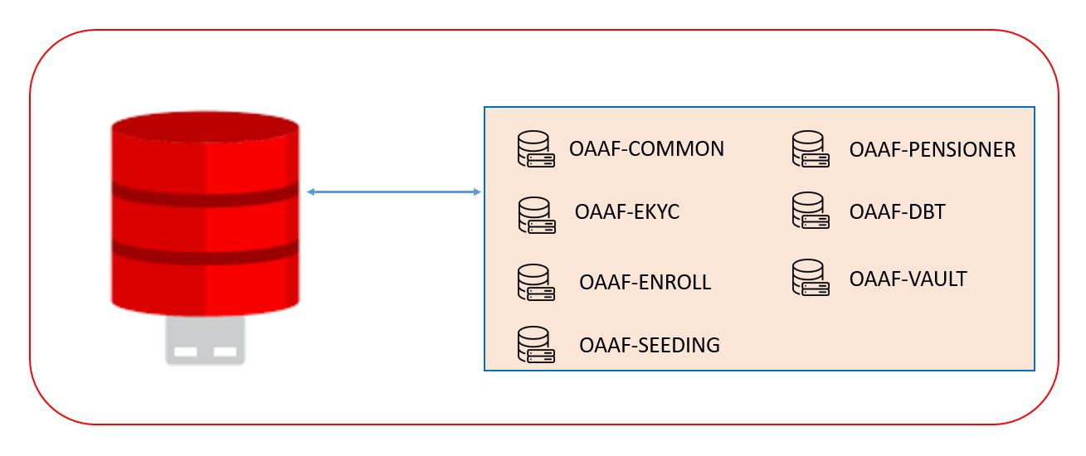

Current Environment Analysis
- Identification of source database and it’s numbers of schemas Identification of objects need to migrate
- Identification object size/magnitude in GB/MB/KB
- Sorting out object’s in smaller to bigger
- Identifying major changes of data type
- Taking record counts of each object’s before migration
- Identification of each objects constraints primary key foreign key check and null constraints
- Identification of table objects comments
- Identification lob object’s like XML Data type, image store and other’s pdf store data type.
- Each schema object’s counts and identification of require object’s which need to be migration list preparation.
- Plan to preparation of object’s ddl scripts and it’s list
- Small to large object’s migration listing
- Scripting to enforce database integrity primary and foreign key.

Migration Approach
- As the database magnitude is high it is proposed to migrate in offline mode and small tables and objects in online mode.
- For the online migration mode approach it is to be ensured, the source object’s metadata reflection on target should exists with all dependencies as exactly like source it’s primary key check constraint’s null constraints and auto incremental sequence generation.
- For offline migration approach, it is required to use tools for capturing source object’s and generate offline scripting to execute on target.
- Both the approach will be taken based on the final object size and feasibility.

Migration strategy
The requirement is to move and relocate the database from on-premises platform to a native cloud platform along with change of one database vender to another database vender that is MySQL server 5.7 to Oracle 19c real application cluster with minimum downtime. Following strategy will be taken for achieve the objectives.
- Setting up pre-production infrastructure on (Odisha state data center)
  - Installation and configuration of MySQL server in a VM for backup copy Restoration
  - Installation and configuration of Oracle Server in a VM for production
  - Configuration of SQL Developer tools in a VM to capture and generate the Scripts of old database
- MySQL backup of old application to be taken
- MySQL backup restoration to be taken and a new MySQL to be installed on the VM
- MySQL database object’s to be captured and script generation using Oracle SQL Developer to be done
- Table data type mapping sheet to be prepared.
- Old legacy system auto incremental sequence with new system setting to be tested and verified
- Data validation and data format specially date, timestamp and null value of tables to be verified and tested
- Application Version-2 connection to be established with Oracle Server to go live .

Activity and Timeline
PRE PRODUCTION ENVIRONMENT
SL # | Activity Name | Start Date | End Date | Responsibility
1 | Source database (MySQL) study | 10-Aug-23 | 25-Aug-23 | CSM DB TEAM
2 | MySQL Schema wise object identification | 28-Aug-23 | 1-Sep-23 | CSM DB TEAM
3 | MySQL database object's script generation | 4-Sep-23 | 5-Sep-23 | CSM DB TEAM
4 | MySQL capture object's script execution on oracle database | 6-Sep-23 | 7-Sep-23 | CSM DB TEAM
5 | Structure data type testing and validation | 8-Sep-23 | 8-Sep-23 | CSM DB TEAM
6 | Referential integrity script execution | 11-Sep-23 | 11-Sep-23 | CSM DB TEAM
7 | Data migration | 12-Sep-23 | 15-Sep-23 | CSM DB TEAM
8 | Tables sequence updation | 16-Sep-23 | 16-Sep-23 | CSM DB TEAM
9 | Testing | 18-Sep-23 | 20-Sep-23 | CSM DB TEAM

PRODUCTION PRE REQUISITE (Responsibility ORACLE along with CSM DB Team)
- Oracle database configuration on ExaCC by Oracle team
- PDB creation on ExaCC
- PDB name: OAAFLIVE(Required for Go Live)
- PDB name: OAAFSTG(Required for Stagging)
- PDB name: OAARPT(Required for Analytics and Reporting)

SL# | PDB | Schemas | HOST | services | Oracle Parameter | Storage
1 | PDBOAAFLIVE | OAAFCOMMON | osrdh.odisha.gov.in | pdboaaflive.odisha.gov.india | SGA-MAX 128G ,PROCESS-2028,SESSION-3096 | 1 TB
1 | PDBOAAFLIVE | OAAFEKYC
1 | PDBOAAFLIVE | OAAFENROLL
1 | PDBOAAFLIVE | OAAFSEEDING
1 | PDBOAAFLIVE | OAAFPENSIONER
1 | PDBOAAFLIVE | OAAFDBT
1 | PDBOAAFLIVE | OAFFVAULT
2 | PDBOAAFSTG | OAAFCOMMON | osrdh.odisha.gov.in | pdboaafstg.odisha.gov.in | SGA-MAX 64G ,PROCESS-2028,SESSION-3096 | 1 TB
2 | PDBOAAFSTG | OAAFEKYC
2 | PDBOAAFSTG | OAAFENROLL
2 | PDBOAAFSTG | OAAFSEEDING
2 | PDBOAAFSTG | OAAFPENSIONER
2 | PDBOAAFSTG | OAAFDBT
2 | PDBOAAFSTG | OAFFVAULT
3 | PDBOAAFRPT | OAFFRPT | osrdh.odisha.gov.in | pdboaafrpt.odisha.gov.in | SGA-MAX 128G ,PROCESS-2028,SESSION-3096 | 1 TB

PRODUCTION ENVIRONMENT
SL # | Activity Name | Start Date | End Date | Responsibility
1 | Oracle PDB Creation table space Creation | 03-Oct-23 | 03-Oct-23 | CSM DB TEAM
2 | Oracle Schema and user Creation | 04-Oct-23 | 04-Oct-23 | CSM DB TEAM
3 | Pre prod all schema backup move to Prod only structure | 05-Oct-23 | 05-Oct-23 | CSM DB TEAM
4 | Data final migration ( 6pm onward) | 12-Oct-23 | 13-Oct-23 | CSM DB TEAM
5 | Tables sequence updation | 13-Oct-23 | 13-Oct-23 | CSM DB TEAM
6 | Object compilation and validation | 13-Oct-23 | 13-Oct-23 | CSM DB TEAM

Backup & Rollback Plan
For safety and integrity of data throughout the migration we will take the backup and rollback if any issue.

Backup

- Database Backup: Before starting the migration process, will take full backup of MySQL database.
- Application Backup: We will ensure a copy of application code, scripts, and configuration files related to MySQL database.

Rollback
Below steps would be taken for rollback.
- Activate MySQL database
- Update application configuration and revert to previous state
- Test rollback and check data consistency

migratiion object

Plan suitable downtime either weekend of or holiday’s estimation of downtime of 15 hours.
Schema wise object List
SL # | Database Schema name | Total Table | Require Table
1 | srdhcommon | 149 | 104
2 | srdhekyc | 5 | 4
3 | pensionrevisiondb | 183 | 87
4 | srdhseeding | 8 | 8
5 | pdsenrollment | 17 | 8
6 | dbt | 41 | 30
7 | srdhVaultlivedb | 12 | 3

Go live Production approx. time of migration with minimum downtime
SL # | Task List | Timing
1 | Pre-prod schema backup restoration | 4 hrs.
2 | Data Migration and Sequence update script execution | 10 hrs.

Post Migration Activities
- Check whether all the schema changes (fields and tables added or removed) as per the new system are updated.
- Migrated data to be tested against the new application
- Data integrity for all objects specially tables to be tested
- The supported functionality in the MySQL to be checked to ensure the system works as expected in the new system through application.
- The data flow within the application to be checked which covers most of the components through new developed application.
- Data mismatch to be verified to ensure cases like data type changed, storing format is changed.

